**WATER LEVEL INDICATOR**

**Circuit diagram:**

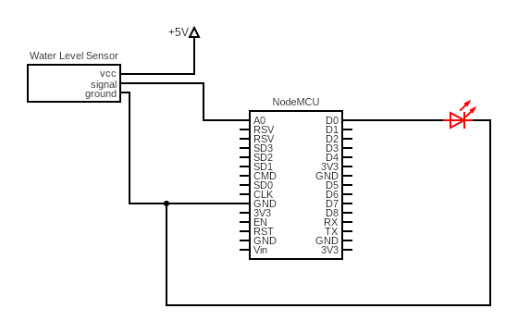

**Working of components**

**NodeMCU Board:**

The NodeMCU ESP8266 development board comes with the ESP-12E module containing the ESP8266 chip having Tensilica Xtensa 32-bit LX106 RISC microprocessor. This microprocessor supports RTOS and operates at 80MHz to 160 MHz adjustable clock frequency. NodeMCU has 128 KB RAM and 4MB of Flash memory to store data and programs. Its high processing power with in-built Wi-Fi and Deep Sleep Operating features make it ideal for IoT projects. NodeMCU can be powered using a Micro USB jack and VIN pin (External Supply Pin). It supports UART, SPI, and I2C interface. The NodeMCU Development Board can be easily programmed with Arduino IoT cloud web editor since it is easy to use. Programming NodeMCU with the Arduino IoT cloud web editor will hardly take 5-10 minutes. All you need is the Arduino IoT cloud, a USB cable and the NodeMCU board itself.

Once you have a personal account on the Arduino IoT cloud, login to your account using the username and password and connect the board with the computer using the USB cable. Now setup the things and dashboard on the cloud and open the Arduino IoT cloud web editor. Then choose the correct board by selecting Boards>NodeMCU 0.1ESP-12 Module (you may have to install a cloud agent for automatic detection of the board) and choose the correct Port. Once the code is loaded into your web editor, click on the ‘upload’ button given on the top bar. Once the upload is finished, you should see the successful output of your IoT project.

**Water Level Sensor:**

The water level sensor is connected to the A2 pin of Arduino. The working of the water level sensor is pretty straightforward. The series of exposed parallel conductors, together acts as a variable resistor (just like a potentiometer) whose resistance varies according to the water level. The change in resistance corresponds to the distance from the top of the sensor to the surface of the water. The resistance is inversely proportional to the height of the water. The more water the sensor is immersed in, results in better conductivity and will result in a lower resistance. The less water the sensor is immersed in, results in poor conductivity and will result in a higher resistance. The sensor produces an output voltage according to the resistance, which by measuring we can determine the water level.

**LED:**

We are using red LED here. The red LED is connected to D0 pin of the NodeMCU module Light-emitting diode simply, we know as a diode. When the diode is forward biased, then the electrons & holes are moving fast across the junction and they are combined constantly, removing one another out. Soon after the electrons are moving from the n-type to the p-type silicon, it combines with the holes, then it disappears. Hence it makes the complete atom & more stable and it gives the little burst of energy in the form of a tiny packet or photon of light.